**DESIGN PATTERNS AND PRINCIPLES**

**Exercise 1: Implementing the Singleton Pattern**

**Scenario:**

You need to ensure that a logging utility class in your application has only one instance throughout the application lifecycle to ensure consistent logging.

**Steps:**

1. **Create a New Java Project:**
   * Create a new Java project named **SingletonPatternExample**.
2. **Define a Singleton Class:**
   * Create a class named Logger that has a private static instance of itself.
   * Ensure the constructor of Logger is private.
   * Provide a public static method to get the instance of the Logger class.
3. **Implement the Singleton Pattern:**
   * Write code to ensure that the Logger class follows the Singleton design pattern.
4. **Test the Singleton Implementation:**
   * Create a test class to verify that only one instance of Logger is created and used across the application.

**SOLUTION:**

**LOGGER CLASS:**

public class Logger {

private static Logger instance;

private Logger() {

System.out.println("Logger instance created.");

}

public static Logger getInstance() {

if (instance == null) {

instance = new Logger(); }

return instance;

}

public void log(String message) {

System.out.println("Log message: " + message);

}

}

**MAIN CLASS:**

public class Main {

public static void main(String[] args) {

Logger logger1 = Logger.getInstance();

logger1.log("This is the first log message.");

Logger logger2 = Logger.getInstance();

logger2.log("This is the second log message.");

if (logger1 == logger2) {

System.out.println("Both logger instances are the same (Singleton confirmed).");

} else {

System.out.println("Different instances exist (Singleton violated).");

}

}

}

**OUTPUT:**

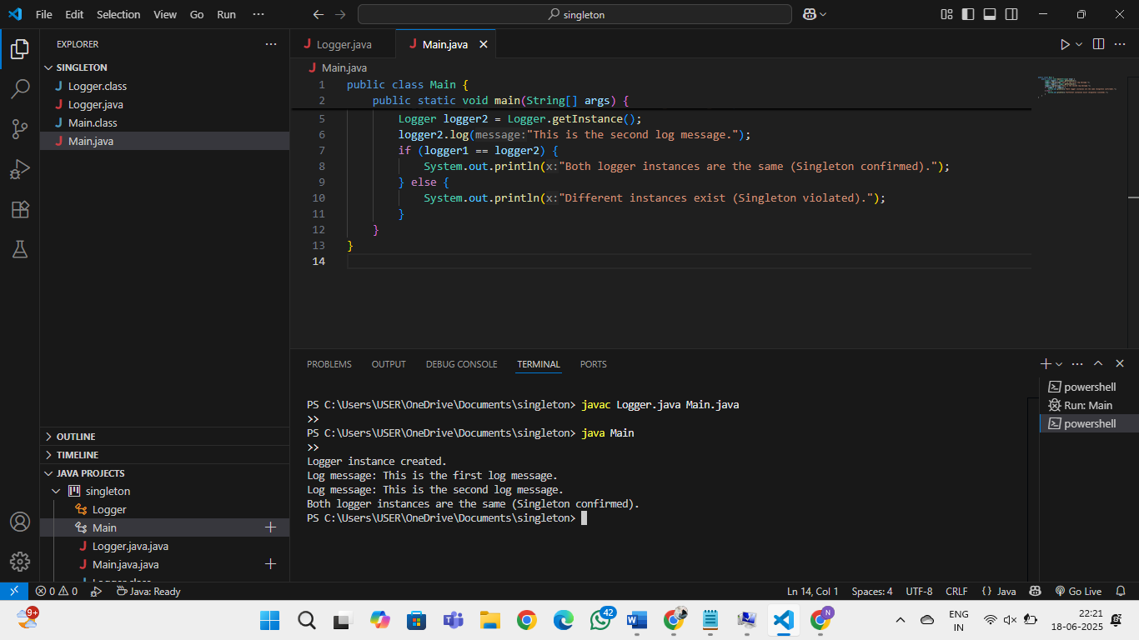

**Exercise 2: Implementing the Factory Method Pattern**

**Scenario:**

You are developing a document management system that needs to create different types of documents (e.g., Word, PDF, Excel). Use the Factory Method Pattern to achieve this.

**Steps:**

1. **Create a New Java Project:**
   * Create a new Java project named **FactoryMethodPatternExample**.
2. **Define Document Classes:**
   * Create interfaces or abstract classes for different document types such as **WordDocument**, **PdfDocument**, and **ExcelDocument**.
3. **Create Concrete Document Classes:**
   * Implement concrete classes for each document type that implements or extends the above interfaces or abstract classes.
4. **Implement the Factory Method:**
   * Create an abstract class **DocumentFactory** with a method **createDocument()**.
   * Create concrete factory classes for each document type that extends DocumentFactory and implements the **createDocument()** method.
5. **Test the Factory Method Implementation:**
   * Create a test class to demonstrate the creation of different document types using the factory method.

**SOLUTION:**

**Document class:**

public interface Document {

void open();

}

**WordDocument Class:**

public class WordDocument implements Document {

public void open() {

System.out.println("Opening a Word document.");

}

}

**PdfDocument Class:**

public class PdfDocument implements Document {

public void open() {

System.out.println("Opening a PDF document.");

}

}

**ExcelDocument Class:**

public class ExcelDocument implements Document {

public void open() {

System.out.println("Opening an Excel document.");

}

}

**DocumentFactory Class:**

public abstract class DocumentFactory {

public abstract Document createDocument();

}

**WordDocumentFactory Class:**

public class WordDocumentFactory extends DocumentFactory {

public Document createDocument() {

return new WordDocument();

}

}

**PdfDocumentFactory Class:**

public class PdfDocumentFactory extends DocumentFactory {

public Document createDocument() {

return new PdfDocument();

}

}

**ExcelDocumentFactory Class:**

public class ExcelDocumentFactory extends DocumentFactory {

public Document createDocument() {

return new ExcelDocument();

}

}

**Main Class:**

public class Main {

public static void main(String[] args) {

DocumentFactory wordFactory = new WordDocumentFactory();

Document wordDoc = wordFactory.createDocument();

wordDoc.open();

DocumentFactory pdfFactory = new PdfDocumentFactory();

Document pdfDoc = pdfFactory.createDocument();

pdfDoc.open();

DocumentFactory excelFactory = new ExcelDocumentFactory();

Document excelDoc = excelFactory.createDocument();

excelDoc.open();

}

}

**OUTPUT:**

